Zagazig University
Faculty of Pharmacy

Summer Training Manual
Bachelor of Pharmacy

TABLE OF CONTENTS

Faculty vision  Faculty mission  Overview  Prerequisites  Training period  Objectives  Aims  Intended Learning Outcomes  Reference Standards  Training Organizations  Responsibilities and expectations  Student's responsibilities  External Supervisor responsibilities  Academic supervisor responsibilities  Student Roles  Assessment  Common Questions  Appendix A (Assignment)  Appendix B (Assessment forms)  Appendix C (Student satisfaction questionnaire on summer training) | Page No  3  3  3  3  3  4  4  5  9  9  10  10  11  11  12  12  13  15  19  22

Faculty Vision:
The faculty of Pharmacy, Zagazig University vision is to be a regionally and globally accredited educational and research institute with a great contribution to the society.
Faculty mission:
The faculty of Pharmacy, Zagazig University aims to provide the local and regional community with highly qualified, multidisciplinary and professional pharmacists with ethical values and able to participate in the development of drug industry and quality assurance as well as contribute to a distinguished health service to the society. This is achieved through developing and upgrading the academic programs, teaching and learning methods, supporting various student activities, developing the abilities of the staff members, their assistants and administrative members, enhancing the oriented applied and scientific research and providing the continuous pharmaceutical education.
Overview:
The role of summer training period is to help the graduates to get a professional pharmaceutical knowledge and skills so that they can contribute to the enhancement for health care and innovation in pharmaceutical sciences and compete effectively in the job market after their graduation.

Prerequisite:
Students must have completed year 3 of the Pharmacy Program.
Training period:
Student should start training in the summer following the third year in which the student spends 300 hours in any pharmacy setting including community or hospital pharmacies, pharmaceutical Firms or research institutes. Number of hours should be not less than 5 hours per day for at least 30 days in a flexible part-time schedule
Objectives
Pharmacy training program was established to provide students experiences and interactions with pharmacists, as well as patients in community settings. Under appropriate supervision students start to develop their knowledge and practical experience in dispensing prescription, drugs storage, counseling patients and responding to their symptoms, health promotion, and medication review. Students will apply pharmaceutical ethics and communication skills and will know how to reduce the harm that drug misuse inflicts on society. Students will have an opportunity to practice giving advice to patient and other health care professionals
in institutional and community pharmacy settings.
Aims
1-Overall Aims of the summer training::
On completion of summer training, students will be able to:
- Outline principles of pharmacy practice, hospital pharmacy, public health interventions, GPMP and pharmacy management, pharmaco-economics.
- Identify properties of different dosage forms, mechanisms of drug action, therapeutic uses, adverse reactions, contraindications, ethical and moral pharmacy laws.
- Demonstrate familiarity with brand and generic drug names, appearance, manufacturer, dosage form(s), and route of administration and therapeutic class for commonly-used drugs, including OTC products (active ingredients and common use).
- Perform calculations required in community/primary care pharmacy practice with accuracy and in a timely manner.
- Address issues related to medication safety
- Handle and use chemical and pharmaceutical materials safely with application of good laboratory practice (GLP) principles in drug manufacture, formulation, design, labeling, storage and distribution of medicinal agents to face market competition.
- Practice basic pharmaceutical care skills: advise health care professionals and patients about the use of drugs and social health hazards of drug abuse and misuse using proper medical and pharmaceutical terms by integrating recent knowledge of pharmaceutical sciences.
- Describe the process of medications distribution, dispensing, compounding and purchasing in the setting of community pharmacy.
- Exhibit good communication skills during interactions with external supervisor, patients, coworkers, and other health care professionals at the site
- Display a positive attitude about the practice of pharmacy, the ability to solve problems and responsibility towards improving self- learning.
- Demonstrate a high standard of professional behavior (i.e., adhering to established work schedule, minimizing absences)
- Potentiate team work, decision making and writing report skills.

2-Intended Learning Outcomes (lLOs):

A- Knowledge and Understanding
a1 | Identify the principles of pharmacy practice such as community pharmacy, complementary and alternative medicines, drug and poison information, pharmacy laws and regulations.
a2 | Describe the properties of different dosage forms and formulations.
a3 | Identify good pharmaceutical manufacturing practice (GPMP) and quality assurance in different pharmaceutical processes (production, packaging, labeling and distribution).
a4 | Outline fundamentals of hospital pharmacy including drug distribution system, drug monitoring, adverse effects, patient counseling and dose adjustment.
a5 | Specify the basics of public health relevant to the community which include measures for prevention of disease, health promotion, raising public awareness for the safe use and disposal of medicine.
a6 | Illustrate the mechanisms of action of drugs, and their therapeutic uses, adverse reactions and contraindications.
a7 | Mention the principles of management and capital requirement including human resources, purchasing and financing new pharmaceutical institute.
a8 | List basics of pharmacy management including sales, marketing, drug promotion; accounting, pharmaceutical business administration and pharmaco-economics.
a9 | Define the concepts of pharmacy practice, including patient profiles, proper documentation and drug filing system.
a10 | State the laws that govern and affect pharmacy practice, ethical principles and moral rules of pharmacy profession.
B- Professional and Practical Skills
b1 | Use effectively proper medical and pharmaceutical terminologies and abbreviations in pharmacy practice.
b2 | Handle and dispose chemical and pharmaceutical materials safely with application of good laboratory practice (GLP) principles.
b3 | Use the chemical and the pharmaceutical materials properly either in drug manufacture, formulation, design, labeling, storing and distribution of medicinal agents with application of good manufacturing practice (GMP) principles.
b4 | Select medicines in accordance with understanding of disease etiology and pathophysiology.
b5 | Perform standard industrial and/or pharmaceutical instrumentation and laboratory techniques in quality control of pharmaceuticals.
b6 | Advise health care professionals and patients about rational use of drugs and social health hazards of drug abuse and misuse.
b7 | Apply the relevant knowledge to health care, social care professionals and patients for the safe and proper use of medicine.
b8 | Construct a research study and analyze the results.
b9 | Utilize excellent management of medicines focusing on clinical pharmacy, drug information, uses, adverse reactions, toxicity profiles, maximal and clinical effectiveness and clinical laboratory data.
C- Intellectual Skills
c1 | Apply basic pharmaceutical knowledge in the formulation of safe and effective medicines as well as in the development of new drug delivery systems.
c2 | Establish GLP, (GPMP), good storing practice (GSP), (GPMP) and good clinical practice (GCP) guidelines in pharmacy practice.
c3 | Apply qualitative and quantitative analytical and biological methods for quality control (QC) and assay of raw materials as well as pharmaceutical preparations.
c4 | Solve problems concerning physical and chemical incompatibilities that may occur during drug dispensing.
c5 | Select and assess appropriate methods of infection control to prevent infections and promote public health.
c6 | Implement the pharmacological basis of therapeutics in the proper selection and use of drugs in various disease conditions.
c7 | Calculate medicine doses and describe dosage regimens.
c8 | Monitor and manage drug interactions and adverse drug reactions.
c9 | Use principles of pharmaco-economics and marketing information for promoting cost/ effective pharmacotherapy.
c10 | Analyze and interpret research results carried out during the training course.
c11 | Analyze and evaluate evidence-based information needed in pharmacy practice.
D- General and Transferable Skills
d1 | Communicate clearly with patients and other health care  professionals by verbal and written means, and simplify  pharmaceutical and medical issues when addressing the public.
d2 | Retrieve and evaluate information from different sources to improve professional abilities.
d3 | Work effectively as a member of team.
d4 | Use numeracy, calculation and statistical methods as well as information technology tools in pharmacy practice.
d5 | Stay up-to-date with the recent pharmaceutical findings and development in pharmacy profession through independent life long continuing education.
d6 | Adopt ethical, legal and safety guidelines in pharmacy practice.
d7 | Develop management skills including financial, sales and marketing.
d8 | Manage time as evidenced by the ability to plan and implement efficient mode of working.
d9 | Implement writing and presentation skills.
d10 | Demonstrate critical thinking, problem solving and decision making abilities.

Reference standard
The faculty is adapting the national academic reference standards (NARS) for pharmaceutical education.

Training organizations
The whole or a part of the summer training can be accomplished in community pharmacies, pharmaceutical and drug companies and in hospital pharmacies. It can also take place in scientific offices of pharmaceutical companies.

1- Community Pharmacy
It provides the student with the opportunity to work closely with a pharmacist under the supervision of academic supervisor chosen by the faculty. The student will be immersed in daily activities with a pharmacy owner and/or director. The student will be exposed to the full range of activities e.g. managerial tasks, patient counseling and community involvement that magnifies the practices of successful community pharmacists.
2- Hospital Pharmacy
Hospital pharmacy training will equip student with the skills of
undertaking medication history interviews and detailed medication management reviews, providing medicines information (at discharge and all points of contact with the healthcare system),
interpreting clinical laboratory results and making recommendations on medicines, working in specialized units e.g. emergency, intensive care, aged care, oncology, pediatrics working in multidisciplinary teams with doctors, nurses and other health professionals.

3- Pharmaceutical Industries
To gain experience in providing safe and effective pharmaceutical products according to GMP regulations and quality control and to identify the most recent techniques in drug formulations.
4- Other Organizations
- Pharmaceutical products marketing companies as medical representative
- Scientific offices

RESPONSIBILITIES AND EXPECTATIONS:

- Student's responsibilities:
- Bear full responsibility of work by getting to work on time and remain throughout all working hours.
- Deal with your colleagues friendly and follow your external supervisor directions honestly.
- Learn basic, advanced knowledge and techniques accurately keeping hand eye coordination to reduce errors.
- Try to be creative by suggesting challenging ideas to develop pharmacy career to be ready for employment competencies.

- external supervisor responsibilities
- Interact with the student and review progress, answer questions, help resolve problems, and review performance in the context of the training’s own goals and objectives.
- Monitor student participation in routine technical work and discussions to achieve relevant assessment.
- Follow up the students interaction with the patients and colleagues
- Observe, evaluate and grade each student’s performance and behavior.
- Immediately contact the academic supervisor to discuss problems or concerns regarding the student training (illness, laziness, bad time keeping).
- Complete the student assessment forms carefully on time and submit them to the academic supervisor. This will identify the individual strengths, weakness and opportunities for improvement.

- Academic supervisor responsibilities:
  - Provide the students with consultation and information helpful in training.
  - Develop and maintain relationships with external supervisor and training organizations to secure appropriate training.
  - Be accessible to students and external supervisor by phone or electronic mail throughout the training period.
  - Encourage students to give constructive feedback regarding the previous academic knowledge and professional sills provided by training.
  - On the basis of the student reports, the student’s self-evaluation, and external supervisor evaluation assess and grade each student’s performance and behavior.
  - Submit all forms and reports of summer training to the general supervisor of summer training.

Student roles
      - Assess yourself by defining and redefining your goals and objectives to make informed choices, and evaluate their own personal and professional growth and development.
      - Apply theories, concepts, and skills learned in the classroom in pharmacy practice settings under the guidance of an experienced supervisor.
      - Update and review your training plan with external supervisor.
      - Obey the regulations of your external supervisor; keep polite and complete 300 hours training.
      - Complete self-evaluation form at the specified time and deliver it to the academic supervisor.
      - Make sure that your external supervisor is aware of the assessment form that must be completed and make an appointment to review the evaluation prior to the last day of training.
      - Fill the summer training assignment forms that include data for different drugs with different therapeutic uses e.g. antispasmodic, diuretic, laxative, antihypertensive………etc. These forms should be completed by students trained at community and/or hospital pharmacies and submitted to the academic supervisor at the end of summer training.

Assessment
Three forms should be filled before the end of training by:
- The external supervisor: (based on student attendance, attitude and participation in patient care activites)
- The academic supervisor: (based on the quality of the summer training assignment and student discussion)
- Each student should also fill self-evaluation form that should be considered for monitoring the summer training system and summer training assignment.

Weighing of Assessment:

Assessment method | Marks | Percentage
The external supervisor | 10 | 20%
The academic supervisor | 15 | 30%
Summer training assignment | 25 | 50%
Total | 50 | 100%

Common questions
1. What should an external supervisor do if there are questions about the training or if problems arise during the training?
The external supervisor should contact the academic supervisor regarding any questions or problems at (002) 055-2303266. When performance problems occur during the training, it is appropriate to meet with the student immediately to share your concerns. This can enhance clarity of expectations and help the focus on areas of expected improvement. It really means dealing with the student as you would perhaps a new employee.

2. Can a student take time off during his or her summer internship?
Students may take time off during their training under the following conditions:
1. They obtain permission from the external supervisor.
2. They are able to complete their 300-hour obligation
3. Their time off does not affect any work time lines set by the external supervisor.

3. How will I evaluate the student at the end of his/her training?
At the end of the summer training, you will complete the assessment form based on observation of student's participation, progress and behavior and submit it to the summer training committee. If you have difficulty filling the assessment forms, contact the academic supervisor who will provide you with easy way to follow instructions on how to complete the evaluation.

APPENDIX A
Training Assignment

Drugs with different therapeutic uses

(Completed by students trained at community and/or hospital pharmacies)

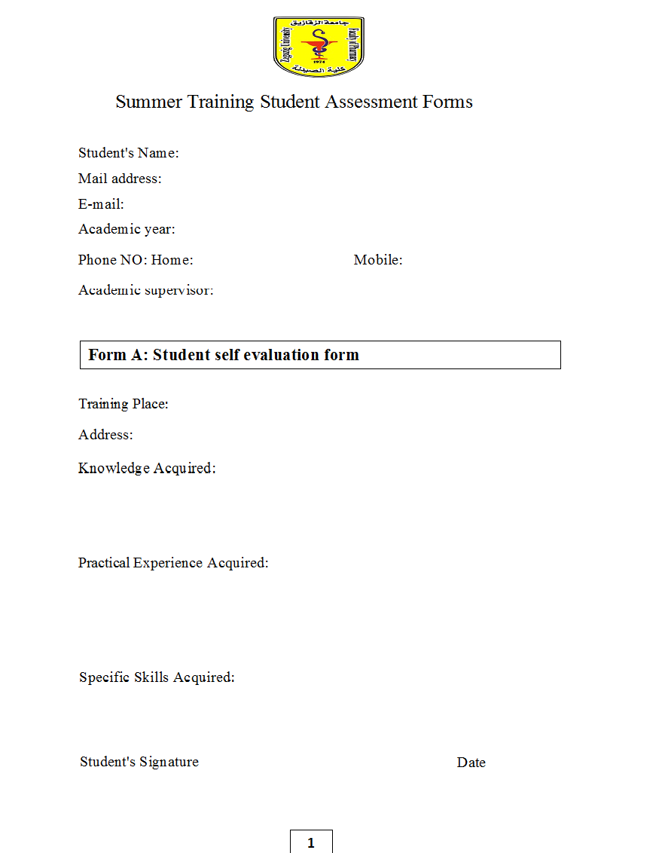

You are supply with the following medicinal categories e.g. : Cardiovascular system, Digestive system, Respiratory system, Skin and dermatological, Urinary system, Analgesic and anti" inflammatory, Central nervous system. Optharnlernlc disorders. Please chose 4 categories and provide 5 commercially pharmaceutical drugs from each group and complete the table information.

Group 1:…………………………………………………………………
No | Trade Named | Active Components | Dosage Form | Company
1
2
3
4
5

Group 2:………………………………………………………………………………
No | Trade Named | Active Components | Dosage Form | Company
1
2
3
4
5

Group 3:…………………………………………………………………
No | Trade Named | Active Components | Dosage Form | Company
1
2
3
4
5

Group 4:………………………………………………………………………………
No | Trade Named | Active Components | Dosage Form | Company
1
2
3
4
5

APPENDIX B

Assessment forms

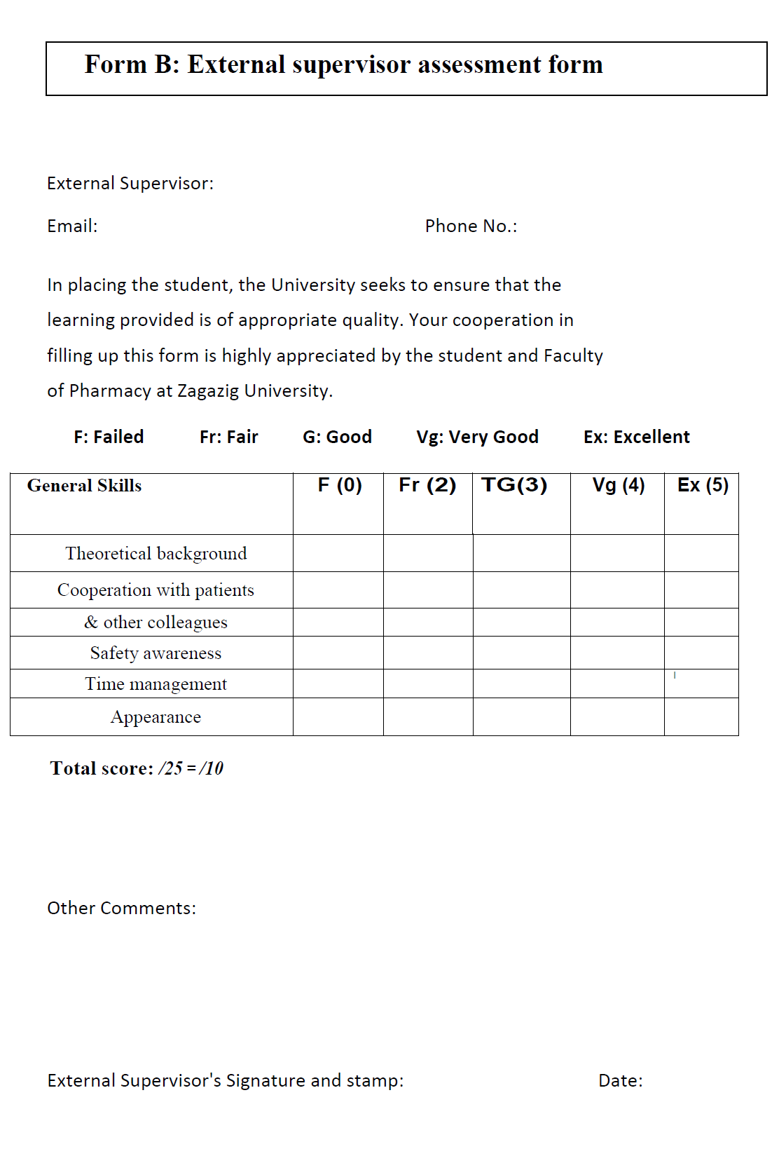
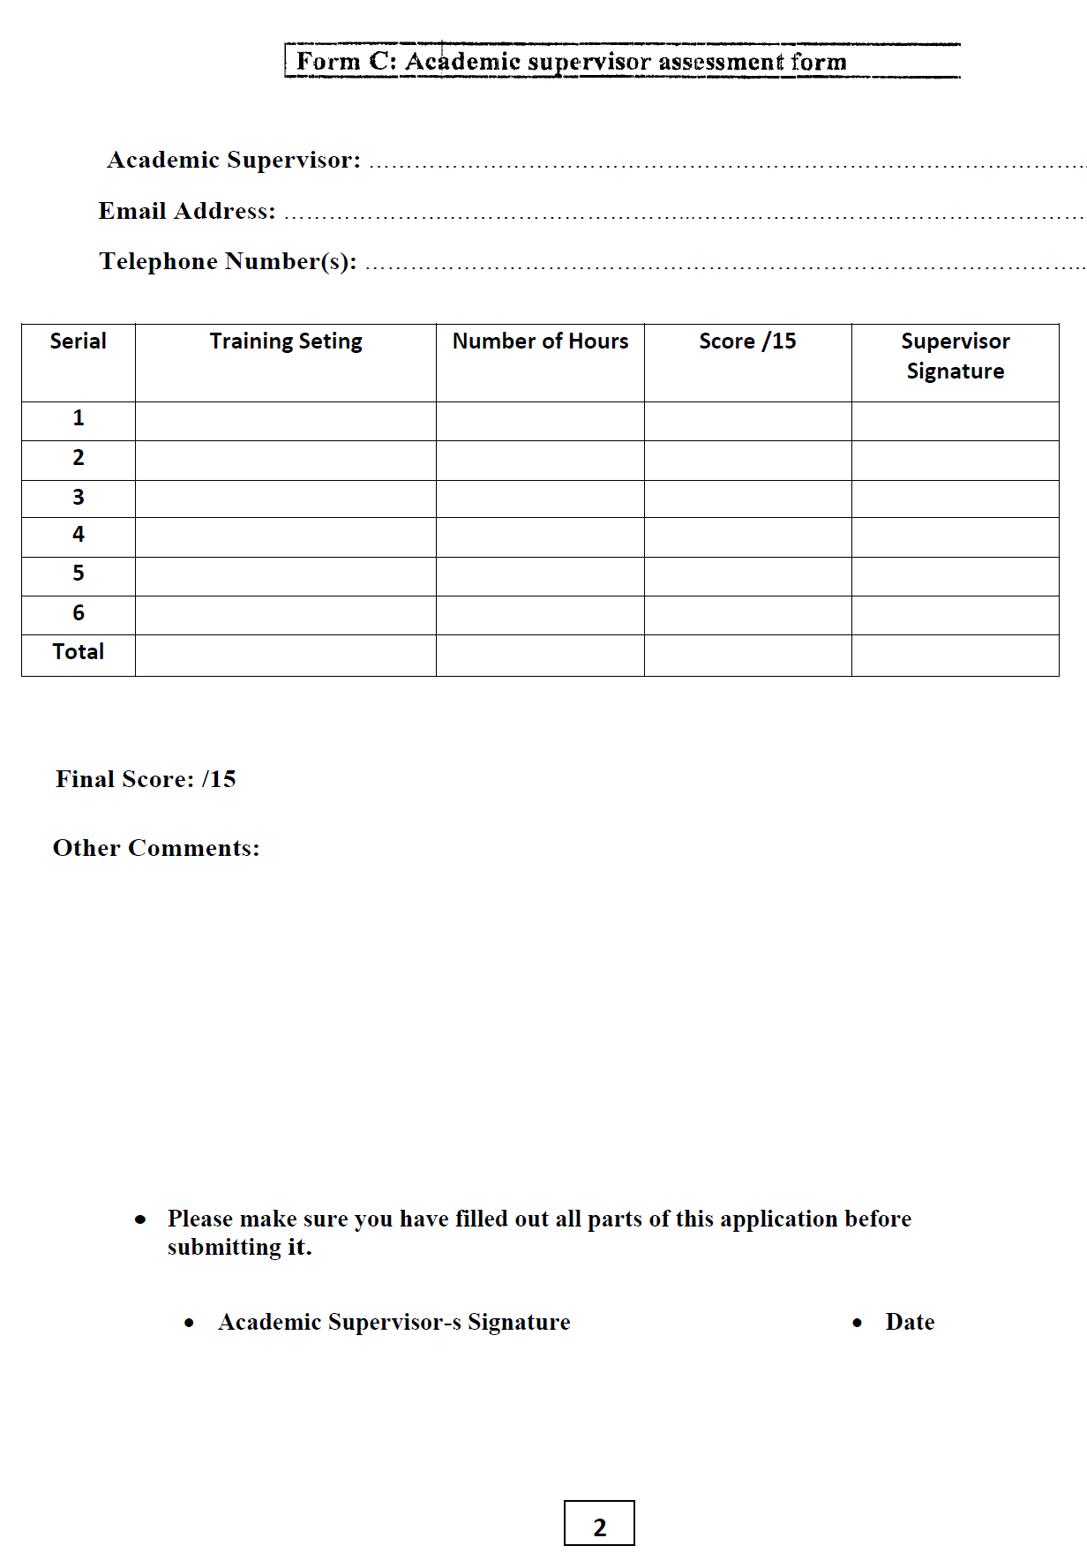

APPENDIX C

Student satisfaction questionnaire on summer training

